Why use Spark instead of Hadoop?



In-Memory Computation → We can use in-memory that Spark has, to process all the data; this is one of the major reasons of replacing Hadoop with Spark. Hadoop uses Disk memory which takes a lot of time.

Lazy Evaluation → Whenever we perform transformations, it will not immediately execute them. It will store the information for all the transformation, create a logical plan according to the optimization, and will lazily evaluate all those transformations and then execute the logical plan once an action is triggered.



Fault Tolerant → We get the ability to trace all the transformations, by this way it provides fault tolerance.

Partitioning → It partitions the data, distributes that data to the cluster of machines.

**What is Apache Spark?**

Apache Spark is a distributed data processing engine. It allows you to process big data quickly across many computers (cluster) using in-memory computing and parallel processing.

Provides a set of libraries for parallel data processing on computer clusters.

Includes libraries for diverse tasks

• SQL & Structured data (Spark SQL)

* Allows querying data using SQL and HiveQL
* Supports various sources of data such as JSON, Hive, JDBC, NoSQL, Parquet, ORC, Delimited

files like CSV etc.

* Allows programmers to intermix SQL with programmatic data manipulations supported by RDDs

within a single application, thus combining SQL with complex analytics.

* A module for working with structured data using SQL.

df = spark.sql("SELECT * FROM table").

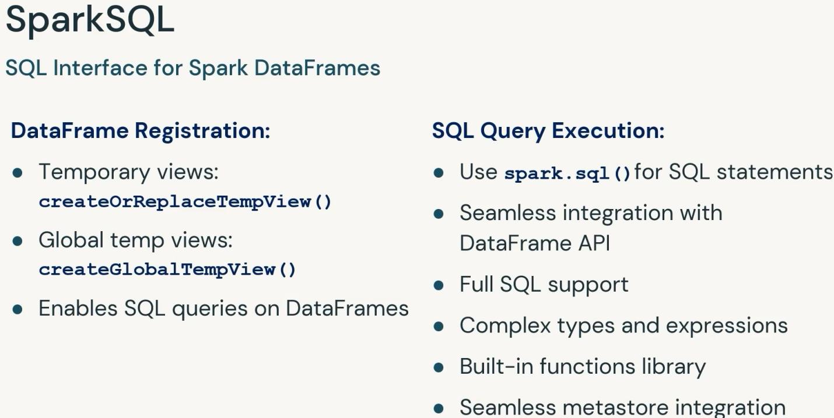

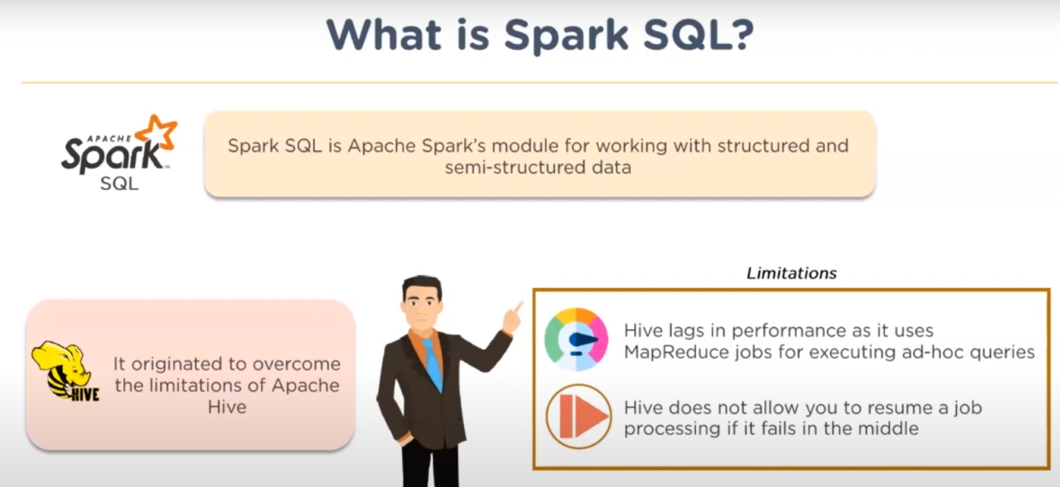

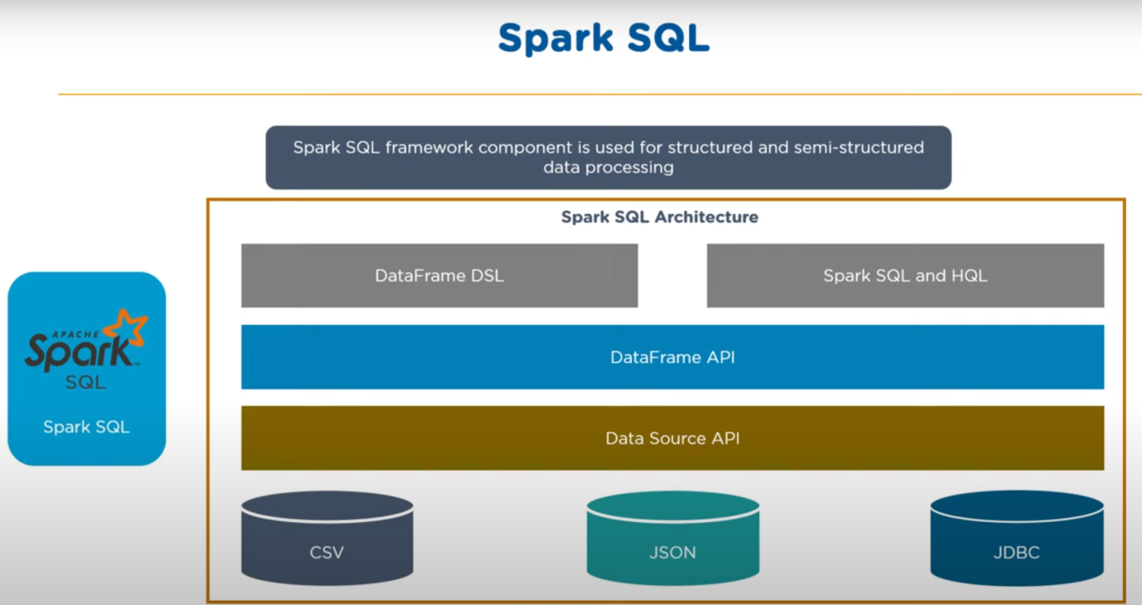

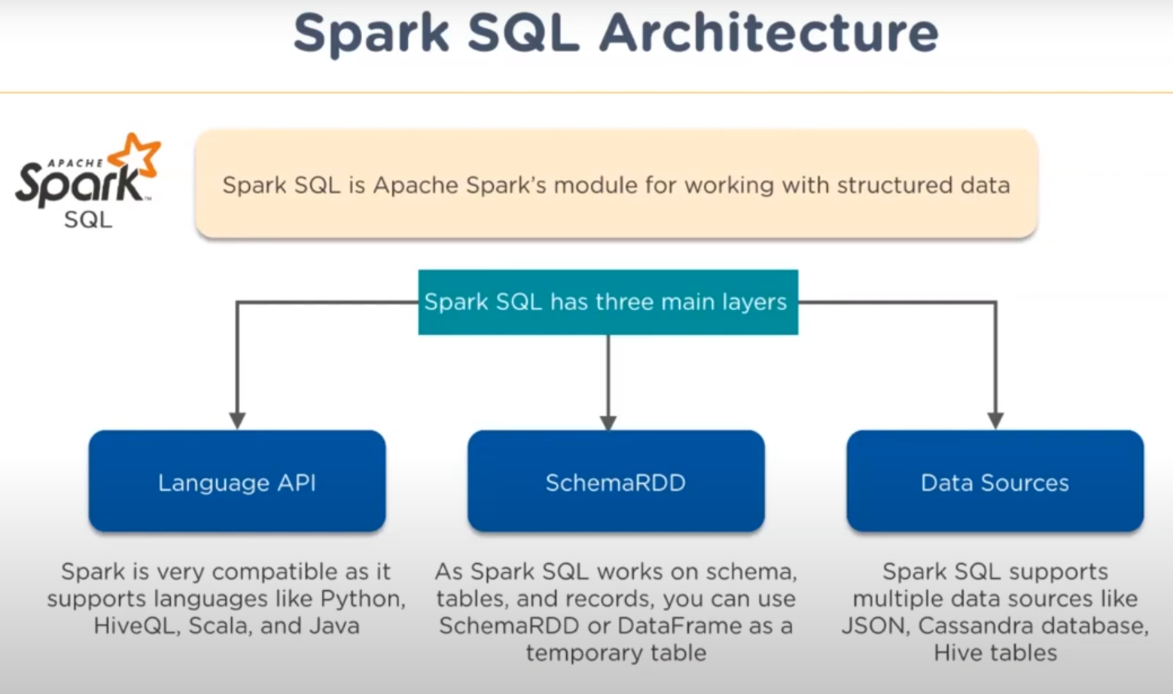

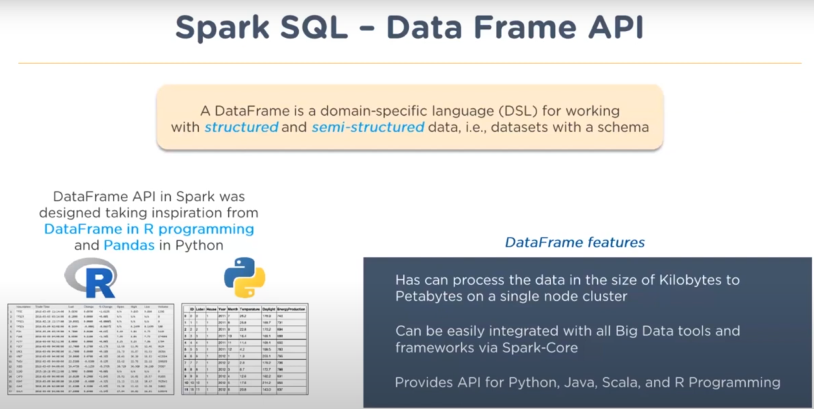

• Machine Learning (MLlib)

* Supports multiple types of machine learning algorithms including clustering, classification, regression and collaborative filtering

• Stream Processing (Spark Streaming and Structured Streaming)

* Allows processing of real time streaming data
* Provides an API for manipulating data streams that closely match the Spark Core’s RDD API

• Graph Analytics (GraphX)

* Library for manipulating graphs and performing graph parallel computations

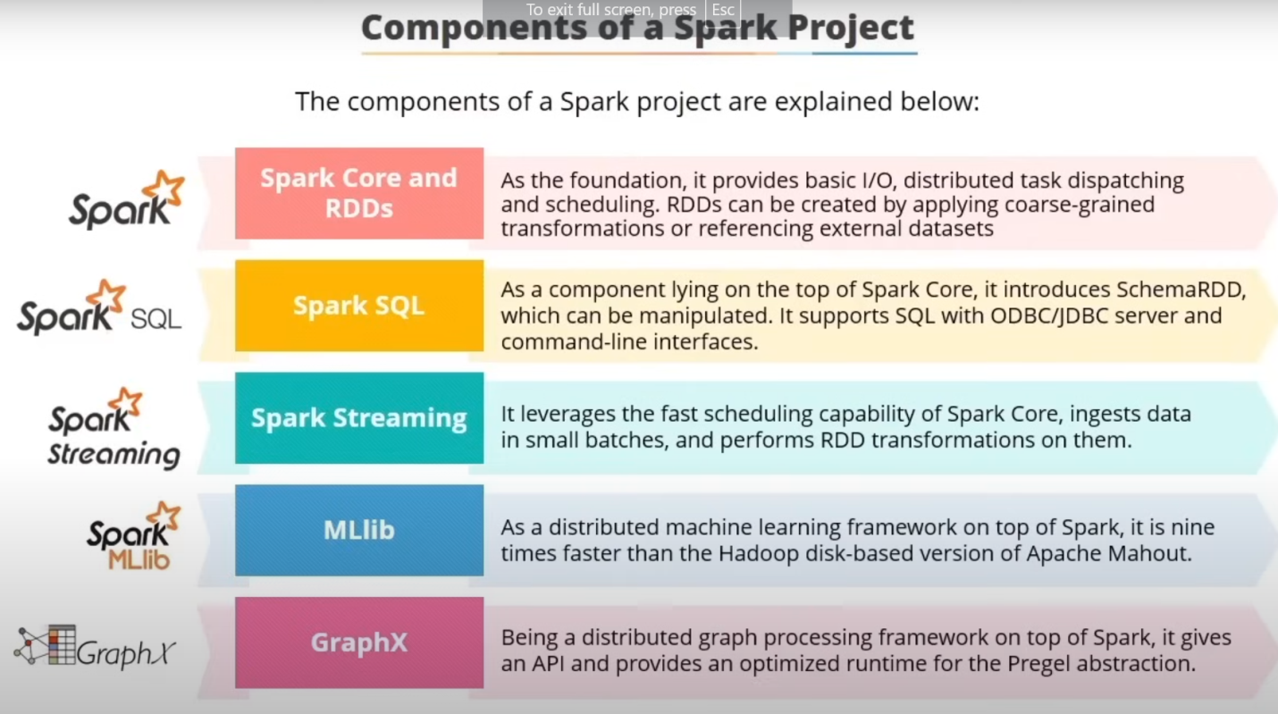

Spark supports multiple programming languages • Python • Java • Scala • R

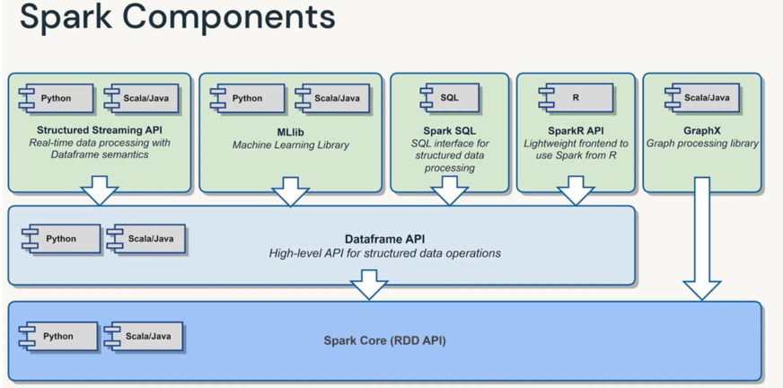

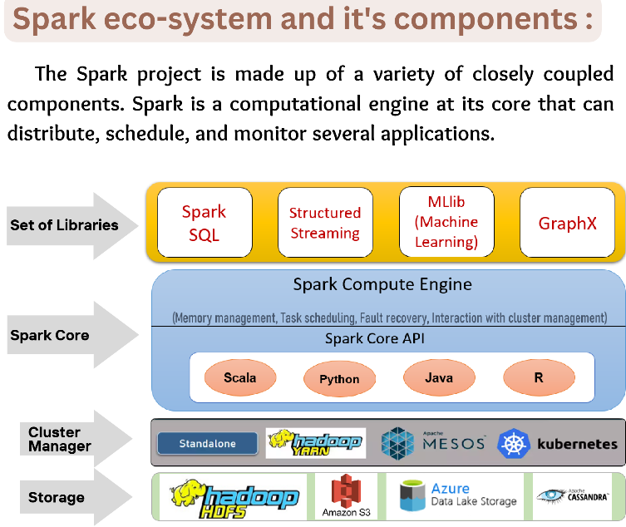

[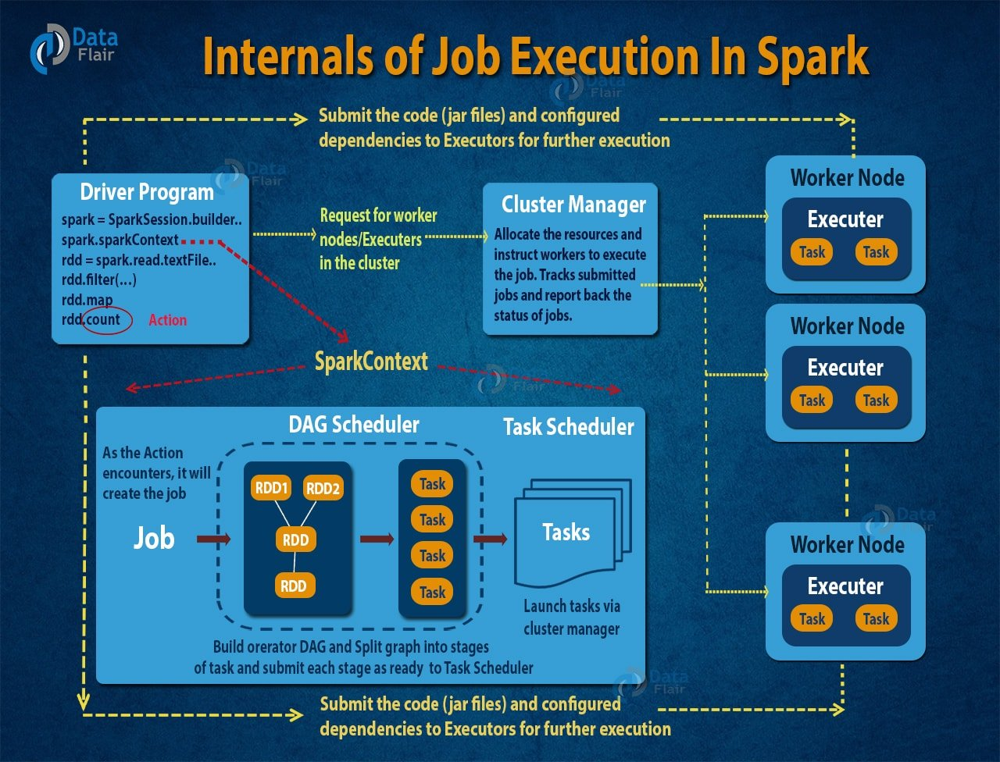](https://data-flair.training/blogs/wp-content/uploads/sites/2/2017/06/internals-of-job-execution-in-apache-spark.jpg)

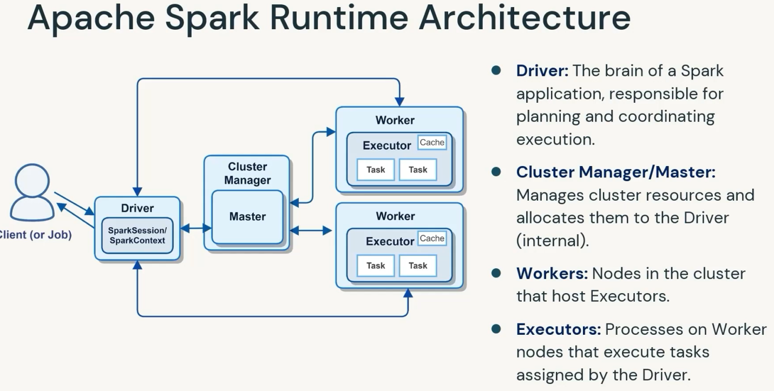

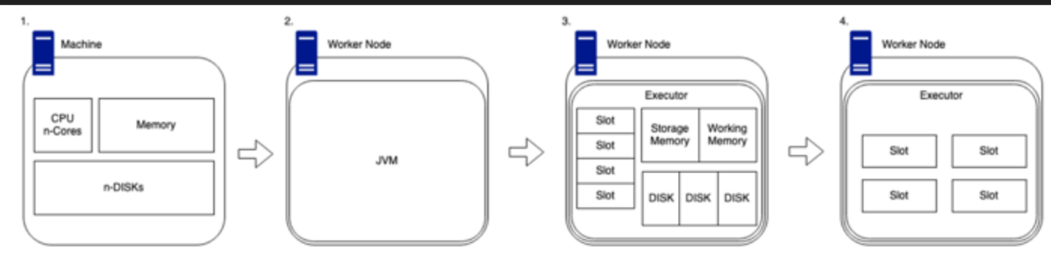

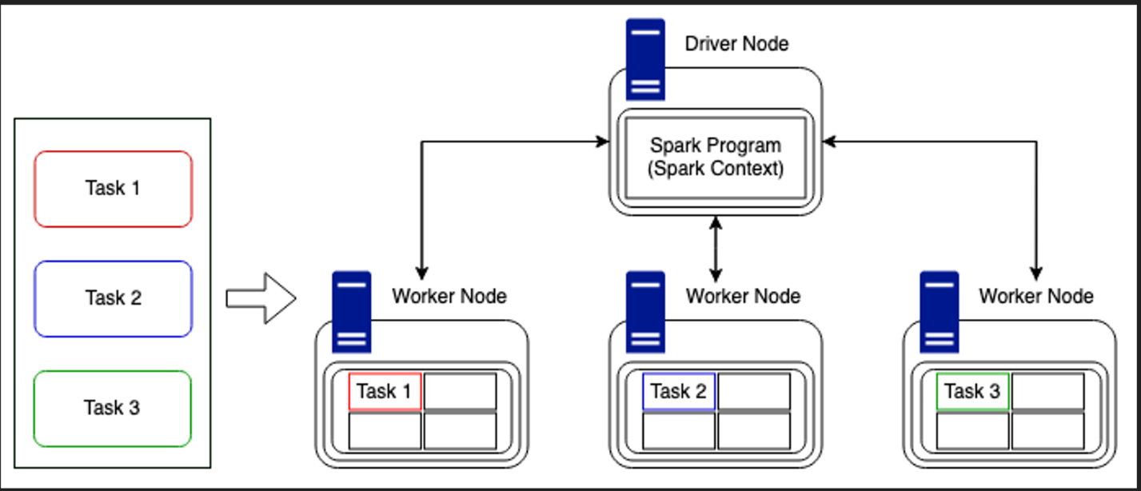

**Spark consists of the following main components:**

* Driver Program
  + The Driver is the main program that runs on the master node and is responsible for coordinating the entire Spark application (The spark program which user written).
  + It creates the Spark Context and coordinates all operations
  + Converts your code into jobs, Breaks jobs into stages and tasks.
  + Sends tasks to executors (tasks executed in parallel on the worker nodes).
  + Tracks progress and failures.
    - **Scheduling tasks**: The Driver is responsible for scheduling tasks to worker nodes, based on the available resources and the requirements of tasks.
    - **Monitoring tasks**: The Driver is responsible for monitoring the tasks and making sure that they are executing correctly. If a task fails, the Driver can reschedule it on a different node.
    - **Gathering results**: The Driver is responsible for gathering results of the tasks and combining them to produce the final result of the application.
  + Analyzes spark application and constructs DAG (Directed Acyclic)
    - Each Job is triggered by an action (e.g., .collect(), .save())
    - Each Action creates a DAG. (A group of tasks that can be executed in parallel are called stages)

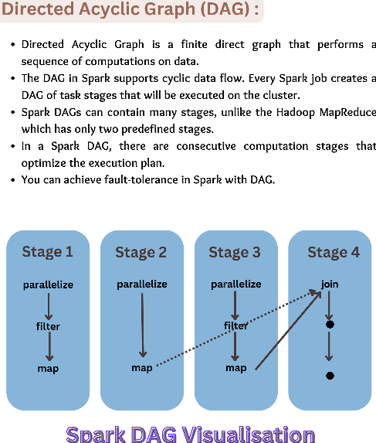

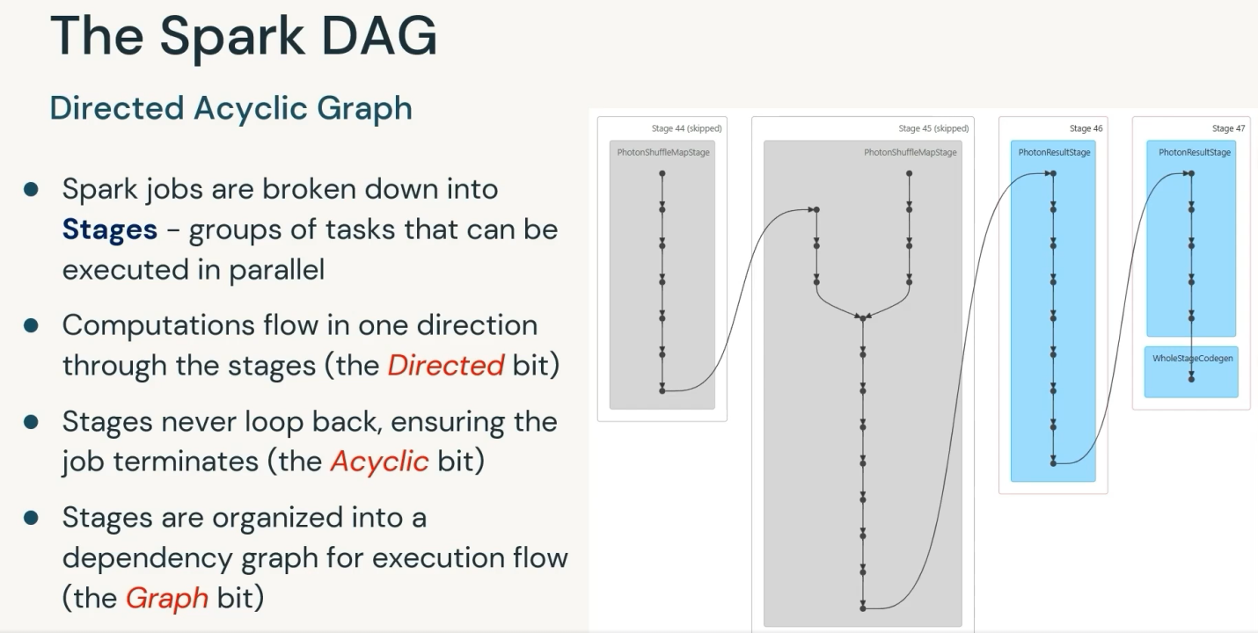







* Cluster Manager // refer below page
* Worker Nodes
  + - Machines in the cluster that do the actual computation.
    - Each worker node runs one or more executors (processes)
* Executors
  + - Processes launched on worker nodes.
    - Do the real work: running tasks, storing data, and communicating with the driver.
    - Executors run for the duration of the Spark application unless they fail
* Job -> Stage -> Task

Job

* + - Triggered by an action (e.g., .collect(), .save())
    - A full job is the end-to-end execution of a data query.

Stage

* + - Jobs are broken into stages.
    - A stage is a set of tasks that can be executed in parallel (based on data shuffling).

Task

* + - The smallest unit of work.
    - One task = one piece of data processed by one executor.
    - **Each partition is processed by a single task on an executor**

**What is Cluster?**

* Single machines do not have enough power and resources to perform computations on huge amounts of information
* A cluster pools the resources of many machines together allowing us to use all the cumulative resources as if they were one.
* Spark is a tool for managing and coordinating the execution of tasks on data across a cluster of computers.
* The cluster of machines that Spark will leverage to execute tasks will be managed by a cluster manager.
* We then submit Spark Applications to these cluster managers which will grant resources to our application so that we can complete our work.

**What is Cluster Manager?**

* Think of it as the "resource allocator" — it chooses which worker nodes will run executors (processes)
* Role: The cluster manager is responsible for resource management in the Spark environment. It allocates resources like CPU and memory across the worker nodes based on the requirements of the driver program.
* Common Cluster Managers:
  + Standalone: Default Spark mode for managing its own cluster.
  + YARN (Yet Another Resource Negotiator): Common in Hadoop ecosystems.
  + Mesos: A general cluster management system.
  + Kubernetes: For containerized environments.
* Key Functions:
  + Resource allocation: The cluster manager allocates and deallocates resources (e.g., CPU cores and memory) for Spark applications.
  + Node monitoring: Monitors the health and availability of worker nodes.
  + Scheduling: Assigns resources to different Spark applications running concurrently.

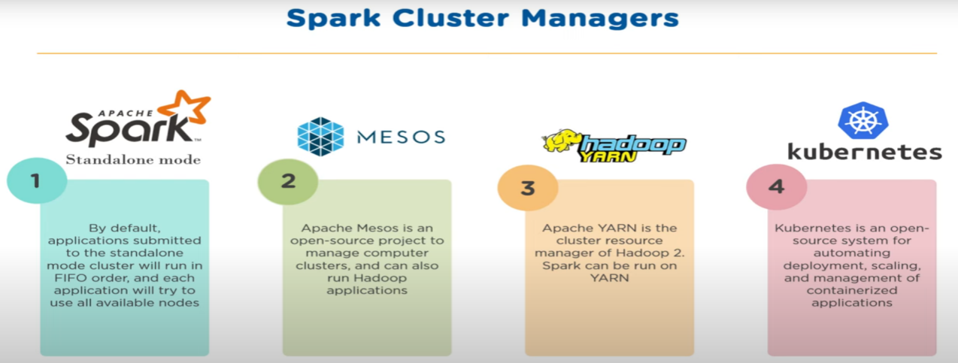

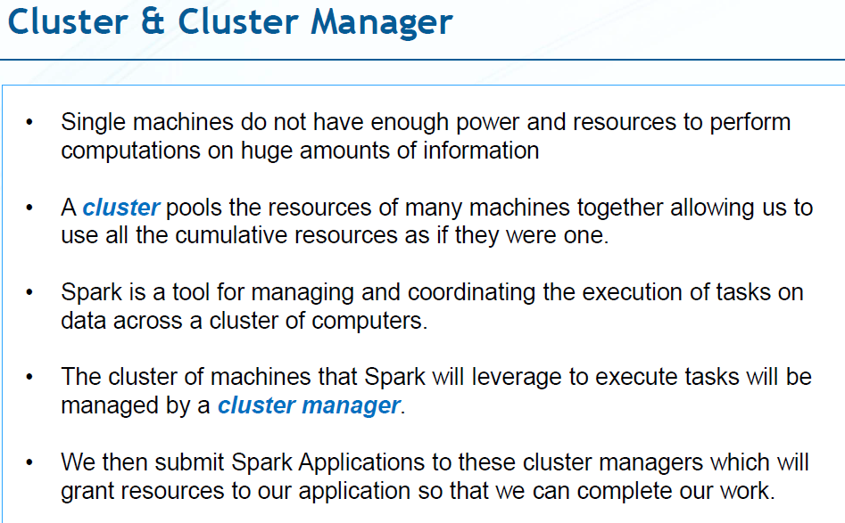

**Spark UI:-**

During Spark’s execution of the previous code block, users can monitor the progress of their job through the Spark UI. The Spark UI is available on port 4040 of the driver node. If you are running in local mode this will just be the <http://localhost:4040>. The Spark UI maintains information on the state of our Spark jobs, environment, and cluster state. It’s very useful, especially for tuning and debugging

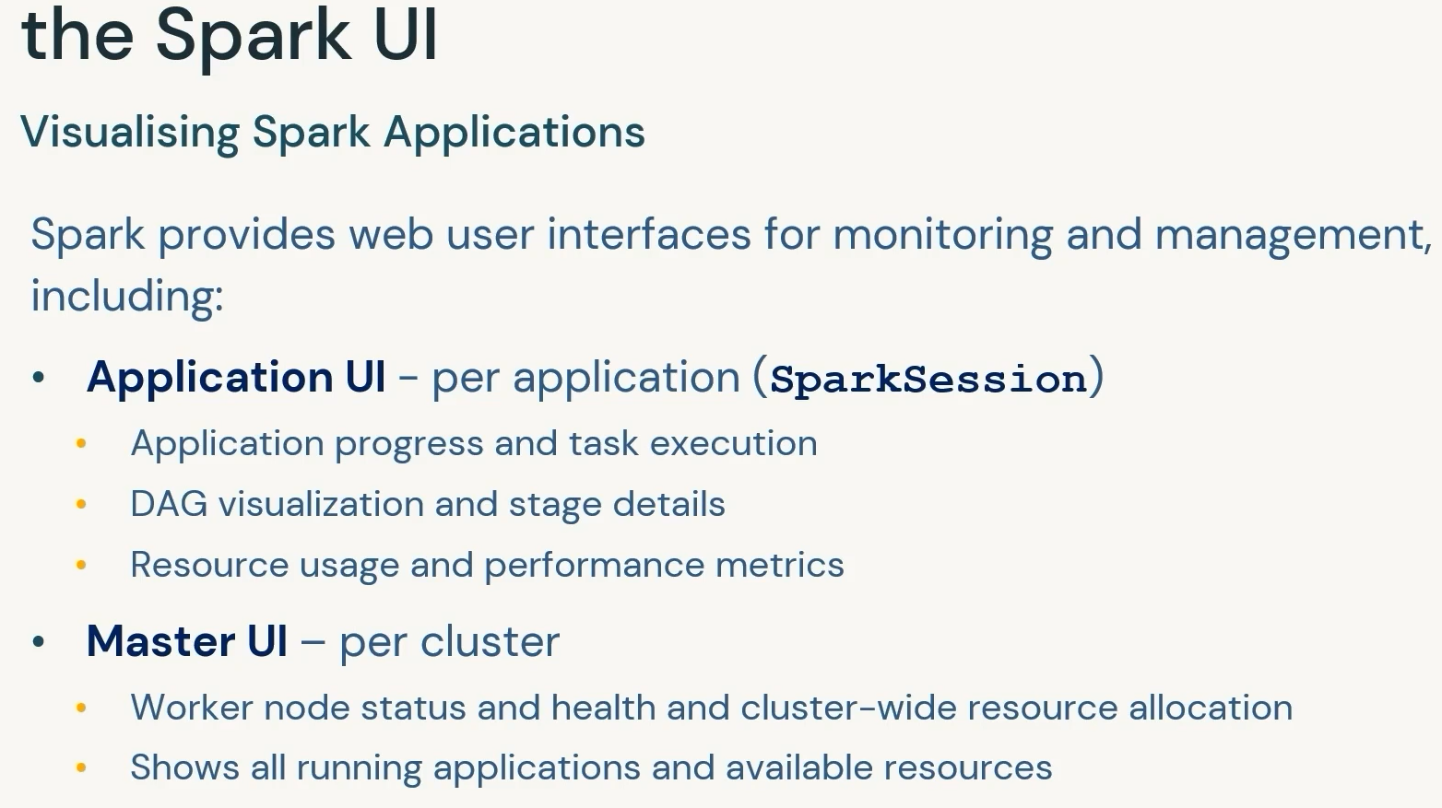

**Spark API’s**

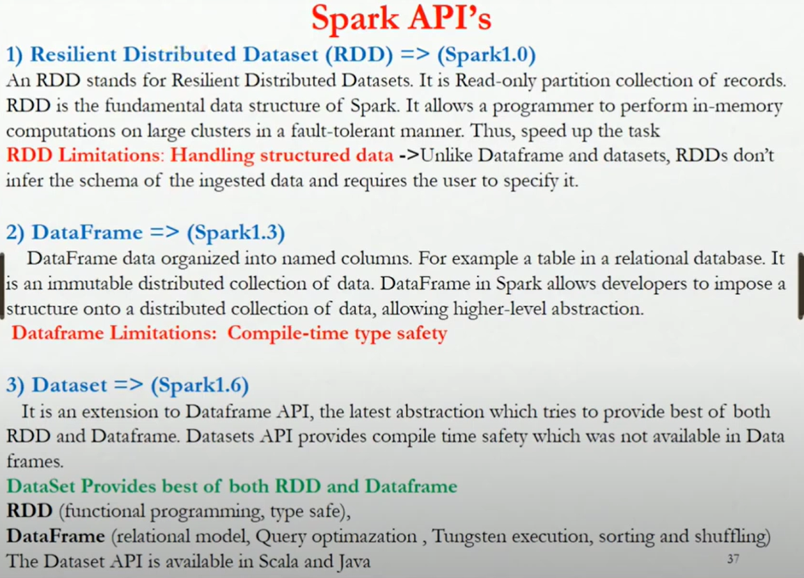

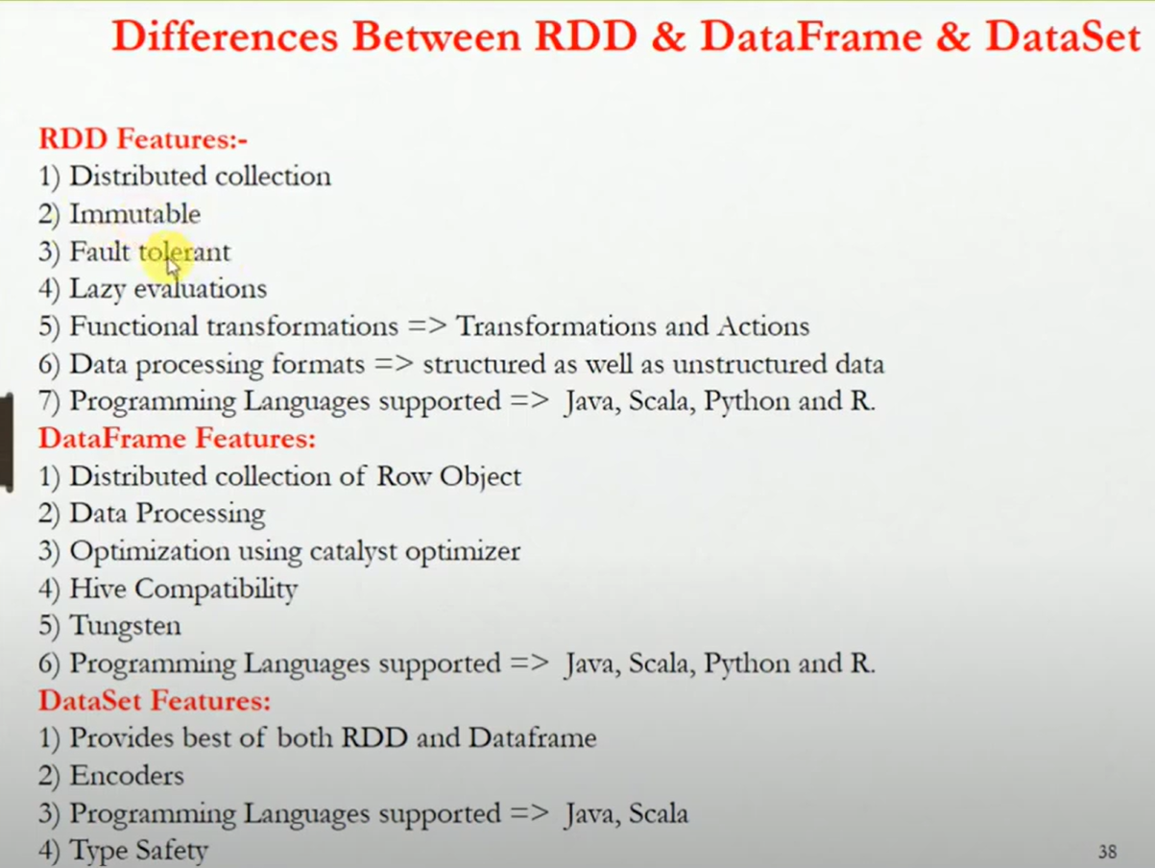

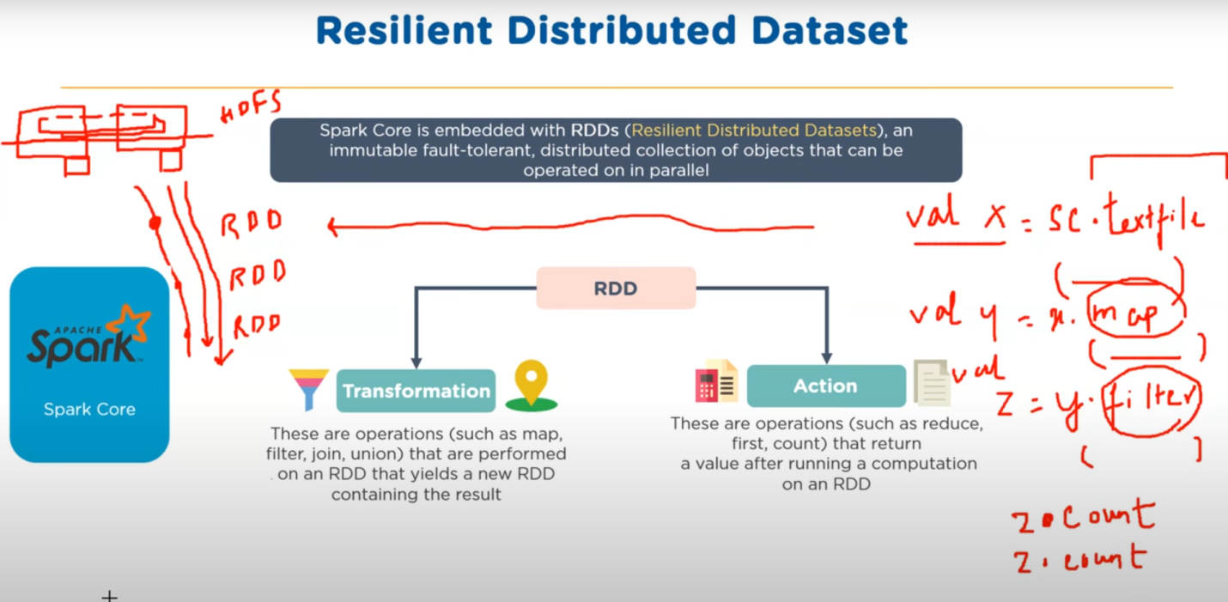

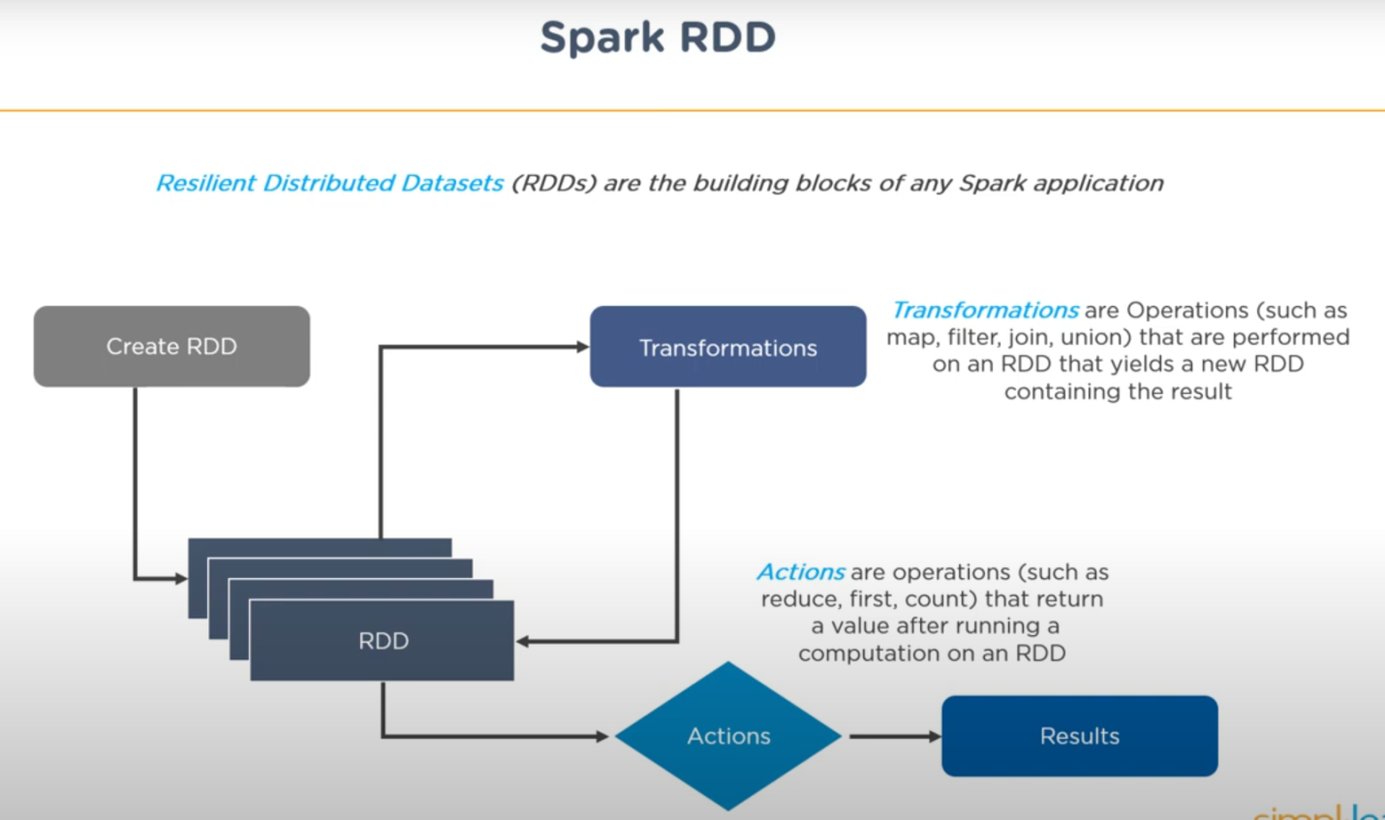

Resilient Distributed Datasets (RDDs)

Immutable distributed collections of objects that can be processed in parallel.

rdd = sc.parallelize([1, 2, 3, 4, 5]).

SparkSession

* We control our Spark Application through a driver process.
* This driver process manifests itself to the user as an object called the SparkSession.
* The SparkSession instance is the way Spark executes user-defined manipulations across the cluster.
* There is a one to one correspondence between a SparkSession and a Spark Application.
* In Scala and Python the variable is available as **spark** when you start up the console.
* The entry point for DataFrame and SQL functionality.
  + from pyspark.sql import SparkSession;
  + spark = SparkSession.builder.appName("App").getOrCreate()

SparkContext

* The entry point to Spark functionality.
  + sc = SparkContext("local", "App")

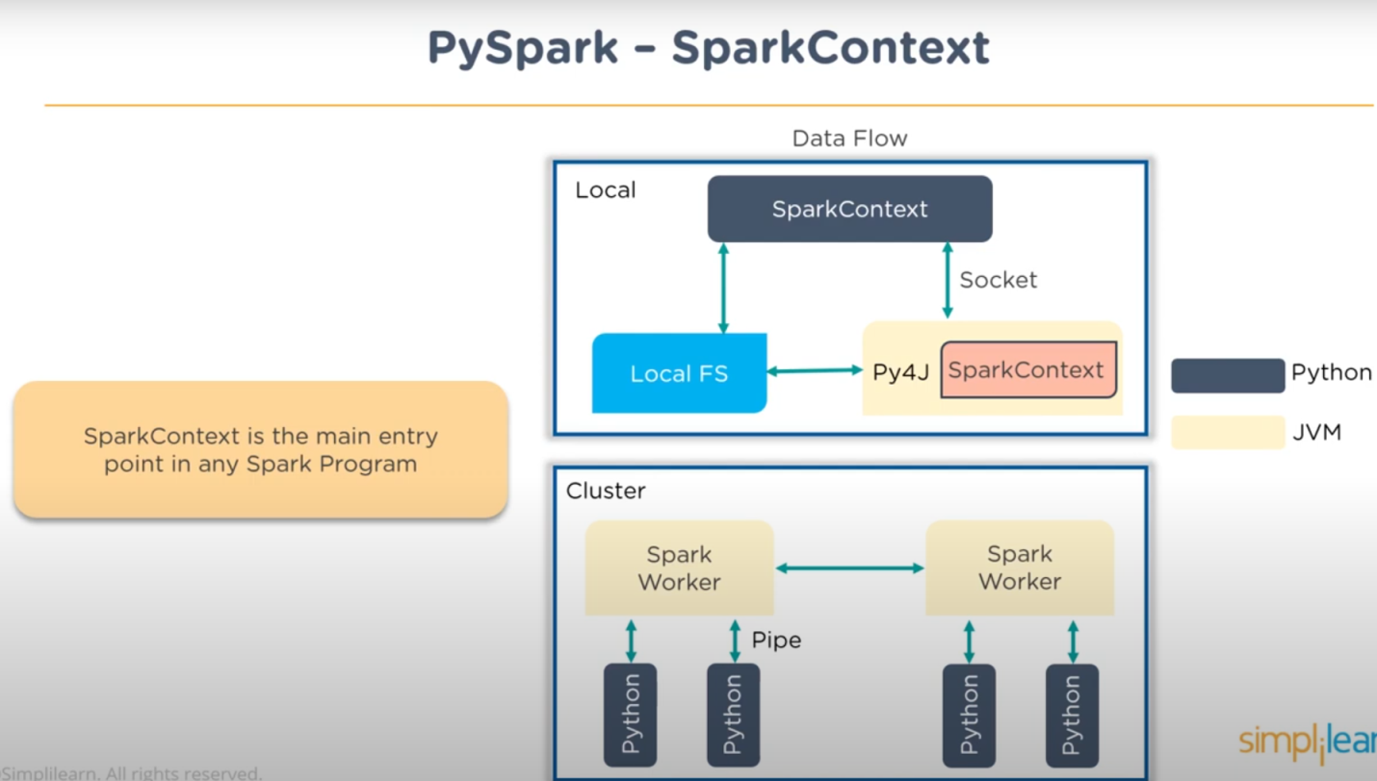

DataFrames

* A distributed collection of data organized into named columns.
  + df = spark.read.json("file.json").
* A DataFrame is the most common Structured API and simply represents a table of data with rows and columns.
* The list that defines the columns and the types within those columns is called the schema.
* You can think of a DataFrame as a spreadsheet with named columns.
* Spark DataFrame can span thousands of computers.

Spark has several core abstractions:

* Datasets
* DataFrames
* SQL Tables
* Resilient Distributed Datasets (RDDs).

These different abstractions all represent distributed collections of data.

The easiest and most efficient are DataFrames, which are available in all languages

Partitions:

* To allow every executor to perform work in parallel, Spark breaks up the data into chunks called partitions.
* A partition is a collection of rows that sit on one physical machine in your cluster.
* A DataFrame’s partitions represent how the data is physically distributed across the cluster of machines during execution.
* If you have one partition, Spark will have a parallelism of only one, even if you have thousands of executors.
* If you have many partitions but only one executor, Spark will still have a parallelism of only one because there is only one computation resource.
* Each partition is processed by a single task on an executor

**Spark decides partitions based on:**

* **File block size**
* **Cluster resources**
* **Operations (e.g., shuffles,joins)**

**Controlling Partitioning**

**Use .repartition(n) for more parallelism.**

**Use .coalesce(n) for fewer partitions.**

**Partitions influence:**

* **Shuffles (data movement across nodes)**
* **Skew (some partitions heavier than others)**
* **Caching efficiency**

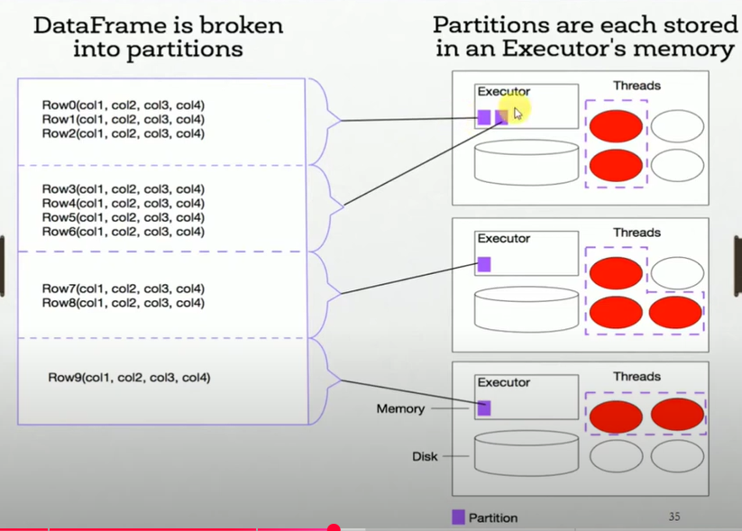

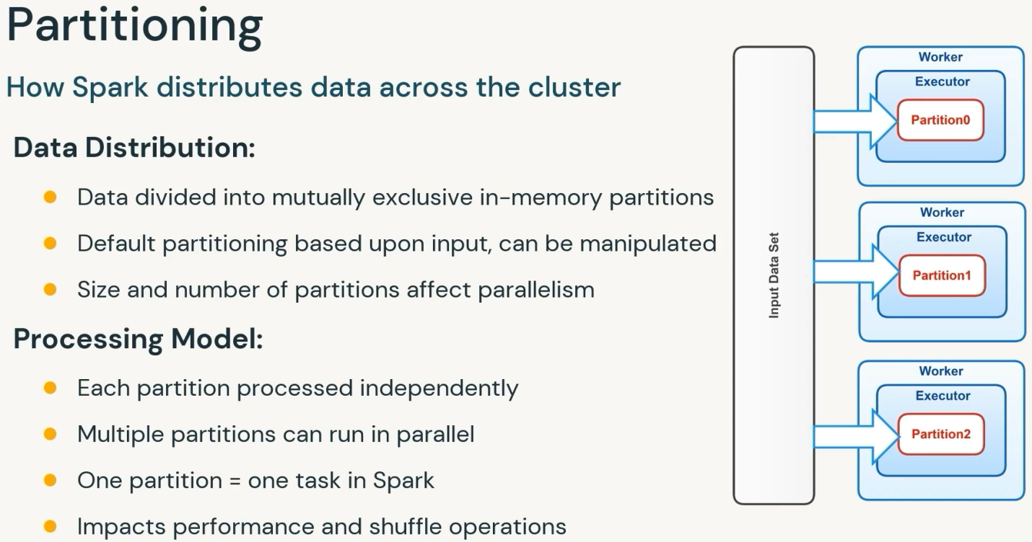

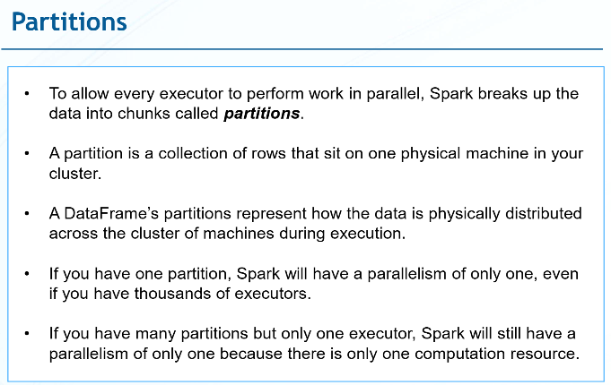

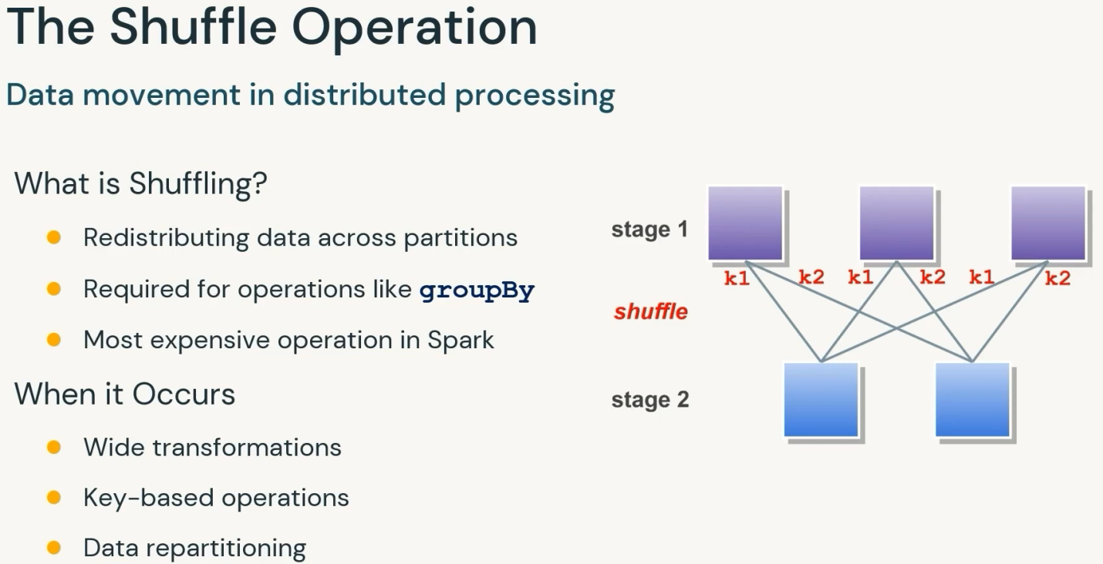

**Shufling : Redistributing data across different nodes, required by certain transformations like reduceByKey.**

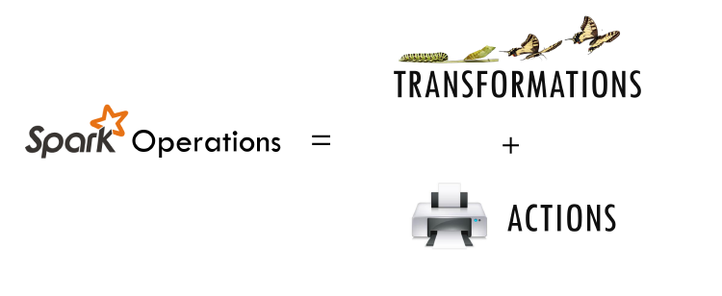

Transformations:

Transformations are operations ( such as map,filter,join,union) that are performed on rdd/dataframe that yields a new rdd/dataframe containing the result.

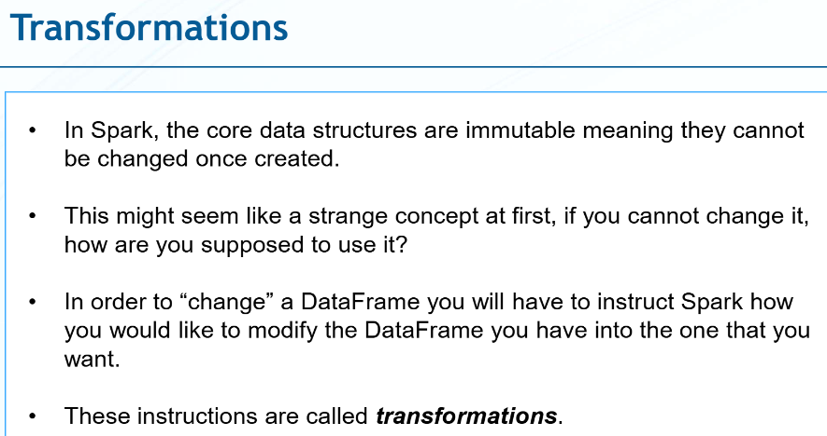



### RDD Operations

You can perform two types of operations on RDD; Transformations and Actions.

[RDD transformations in PySpark](https://sparkbyexamples.com/pyspark/pyspark-rdd-transformations/) are lazy operations and they execute only when an action is called on RDD.

Transformation operations are map, filter, flatMap, groupByKey, reduceByKey, join, union, sortByKey, distinct, sample, mapPartitions, and aggregateByKey. These functions transform RDDs by applying computations in a distributed manner across a cluster of machines and return a new RDD

[RDD actions in PySpark](https://sparkbyexamples.com/pyspark/pyspark-rdd-actions/) trigger computations and return results to the [Spark driver](https://sparkbyexamples.com/spark/what-is-apache-spark-driver/). Key actions include collect, count, take, reduce, foreach, first, takeOrdered, takeSample, countByKey, saveAsTextFile, saveAsSequenceFile, saveAsObjectFile, foreachPartition, collectAsMap, aggregate, and fold. These actions initiate execution and materialize RDD data. Remember any RDD operation that returns non RDD is considered as an action.

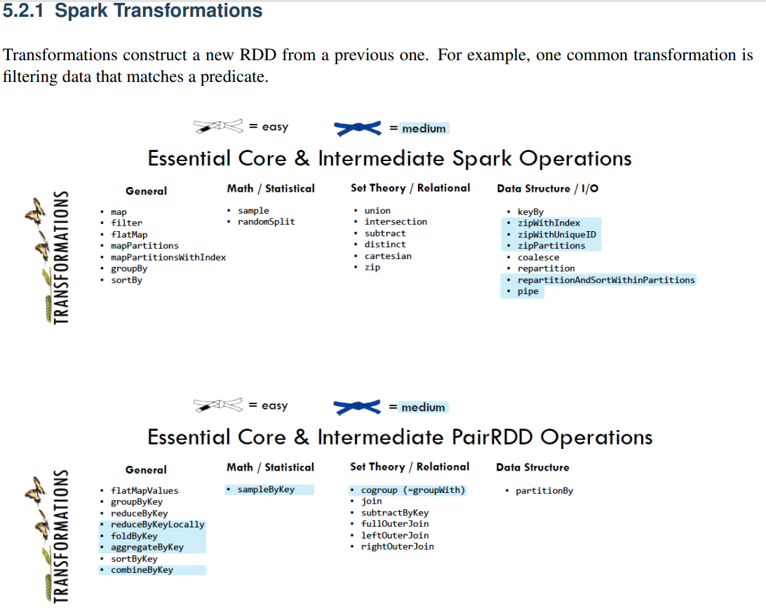

**Spark Paired RDD Operations (refer above PairRDD operations)**

Paired RDD allows the same transformation those are available to standard RDDs. Moreover, here also same rules apply from “passing functions to spark”. Also in Spark, there are tuples available in paired RDDs. Basically, we need to pass functions that operate on tuples, despite on individual elements.

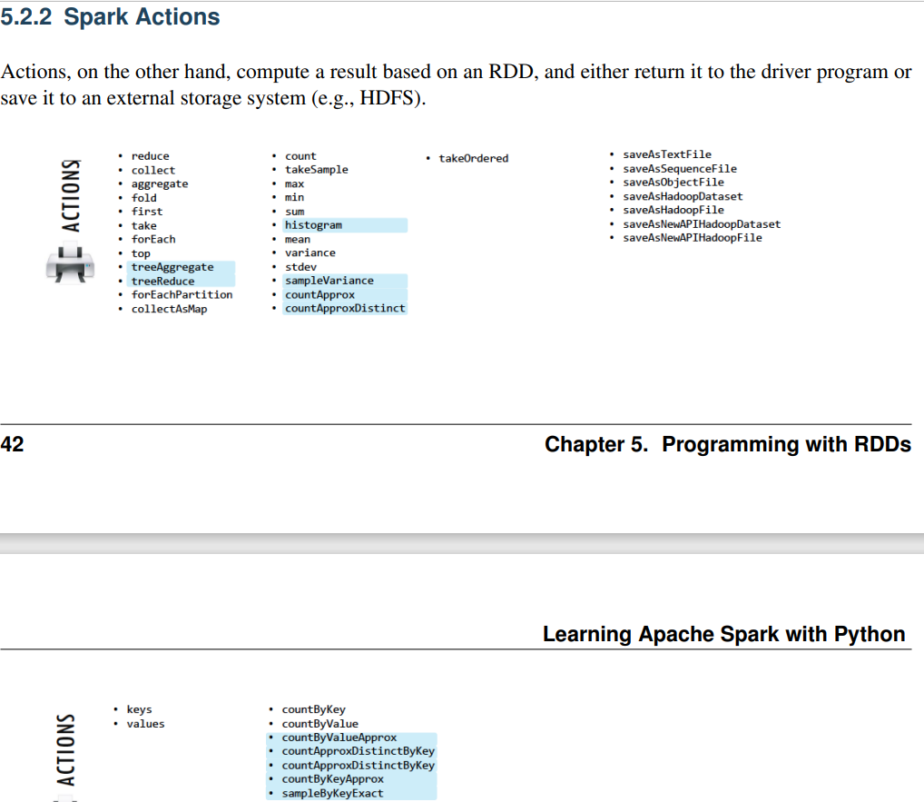

**Types of Transformation**

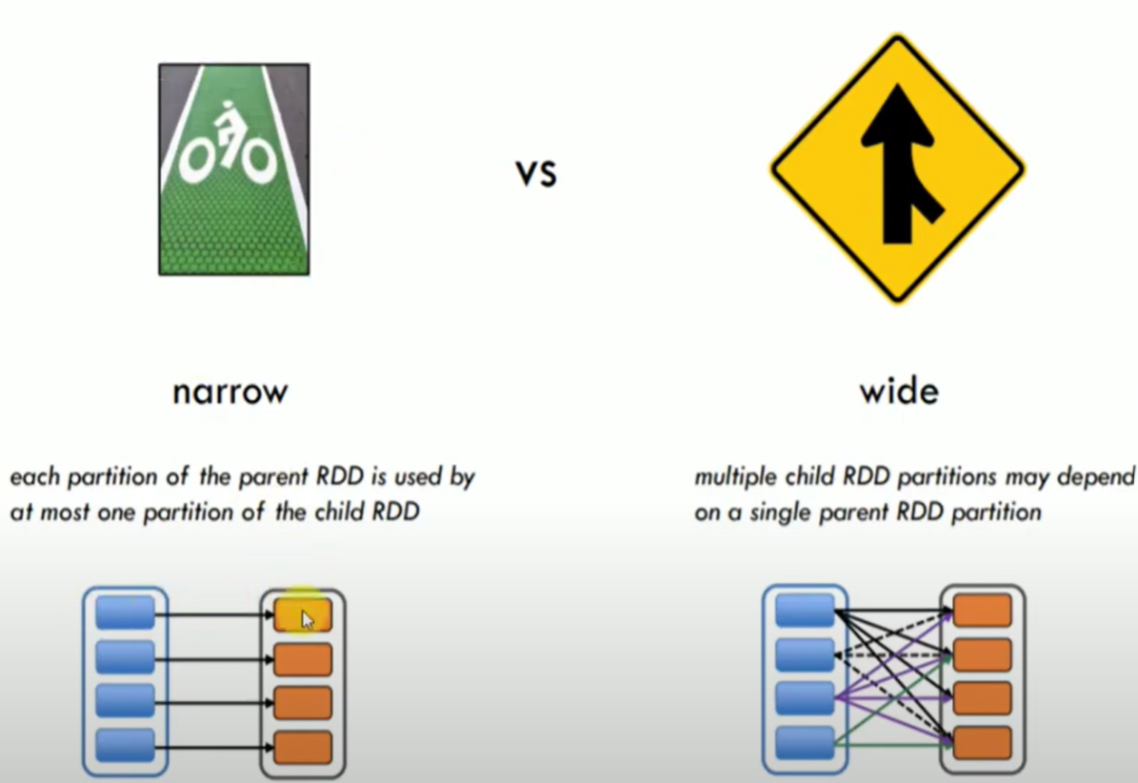

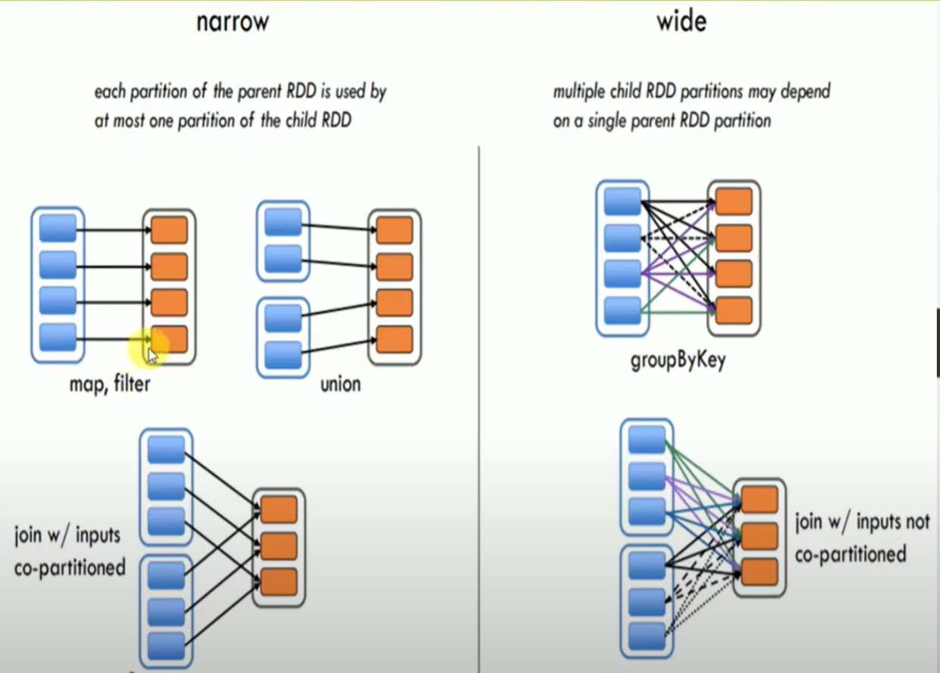

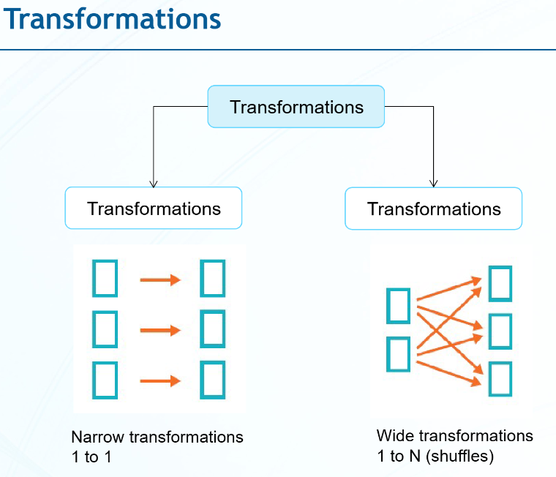

**1.** **Narrow transformations** are the result of map, filter and such that is from the data from a single partition only, i.e. it is self-sustained. An output RDD has partitions with records that originate from a single partition in the parent RDD. Only a limited subset of partitions used to calculate the result. Spark groups narrow transformations as a stage which is called pipelining.**Map,FlatMap,MapPartition,Filter,Sample,Union**

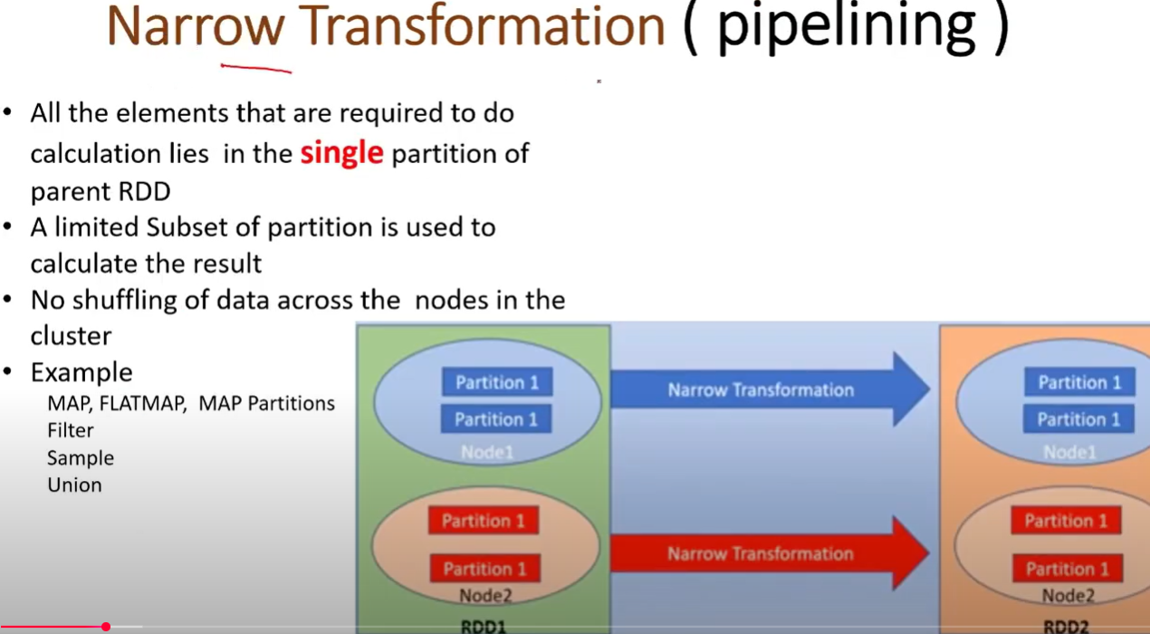

**2.** **Wide transformations** are the result of groupByKey and reduceByKey. The data required to compute the records in a single partition may reside in many partitions of the parent RDD. Wide transformations are also called shuffle transformations as they may or may not depend on a shuffle.**Intersection,Distinct,ReduceByKey,GroupByKey,Join,Cartesian,Repartition,Coalesce**

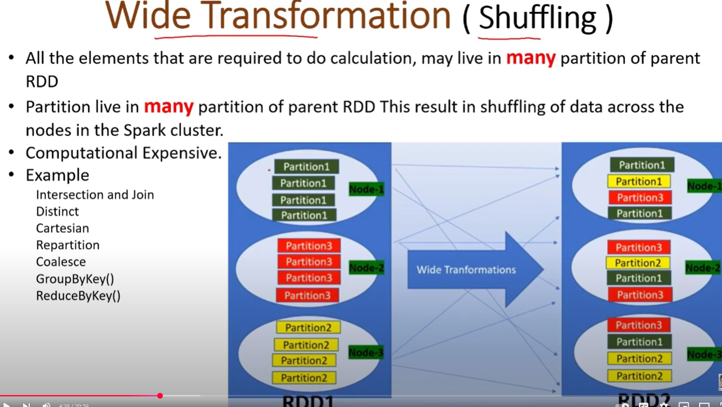

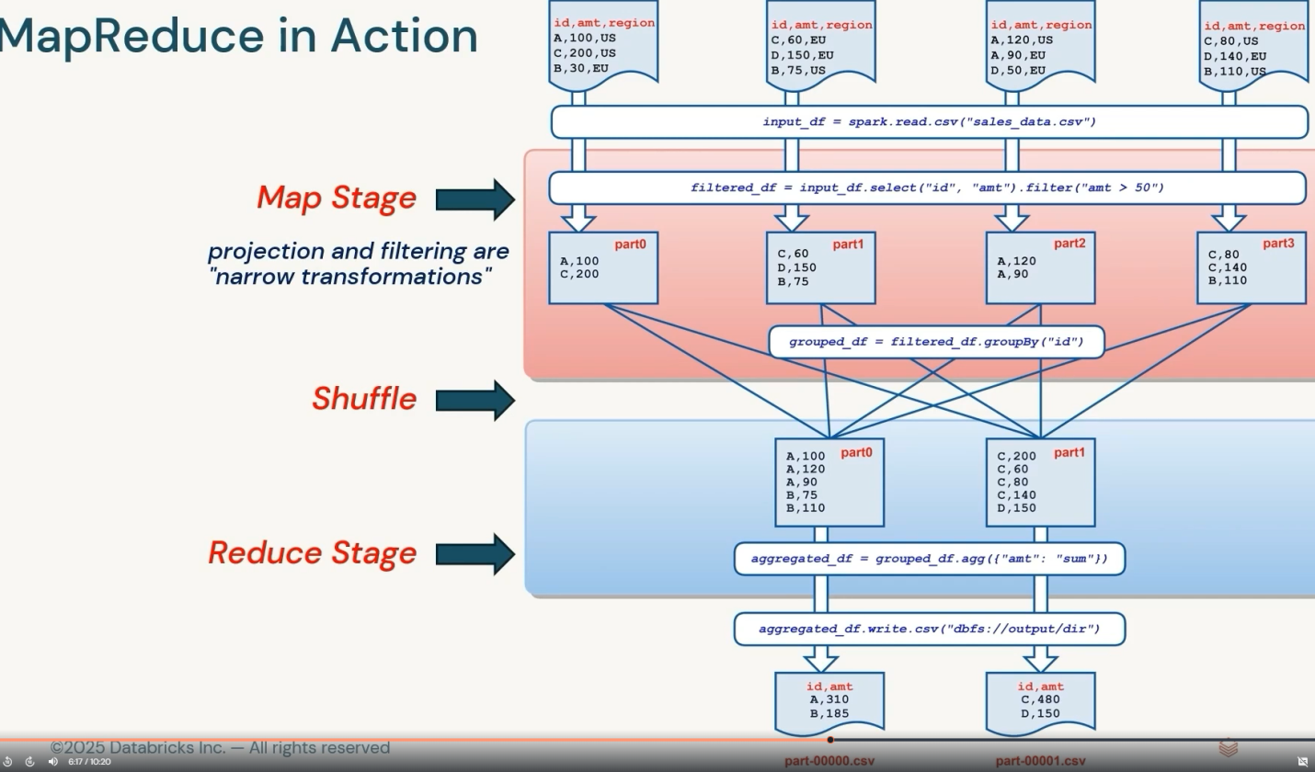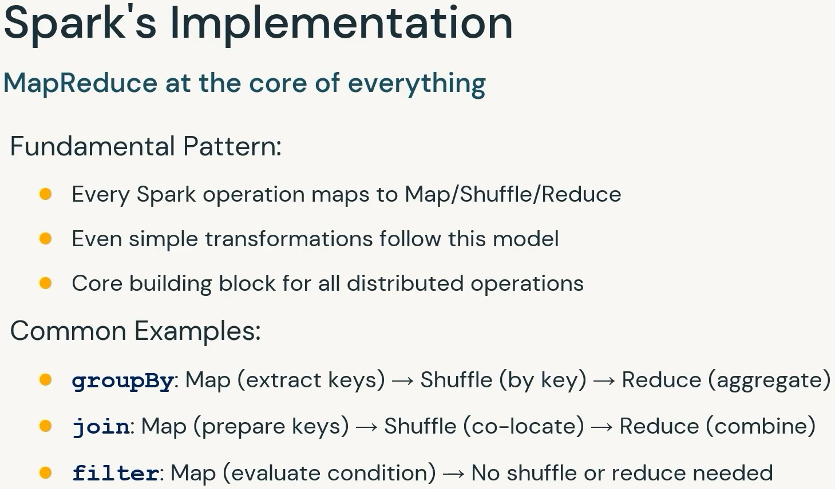

Actions:

Actions are operations ( such as reduce,first,count) that returned a value after running a computation on rdd/dataframe.

Operations that trigger computation and return a result to the driver.

count = rdd.count().

RDD Actions

Actions return final results of RDD computations. Actions triggers execution using lineage graph to load the data into original RDD, carry out all intermediate transformations and return final results to Driver program or write it out to file system.

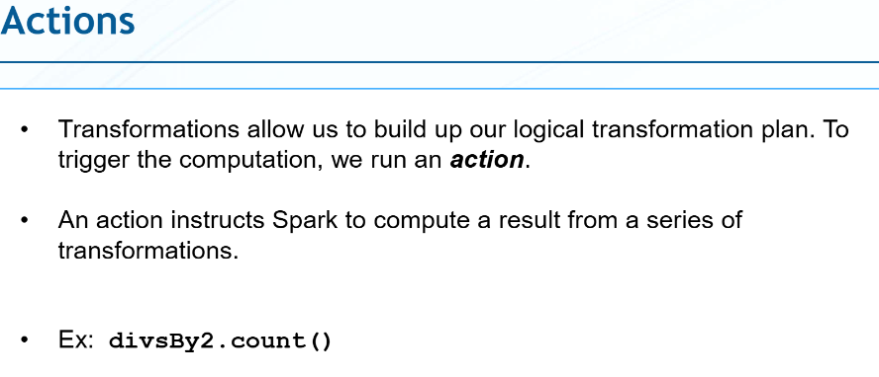

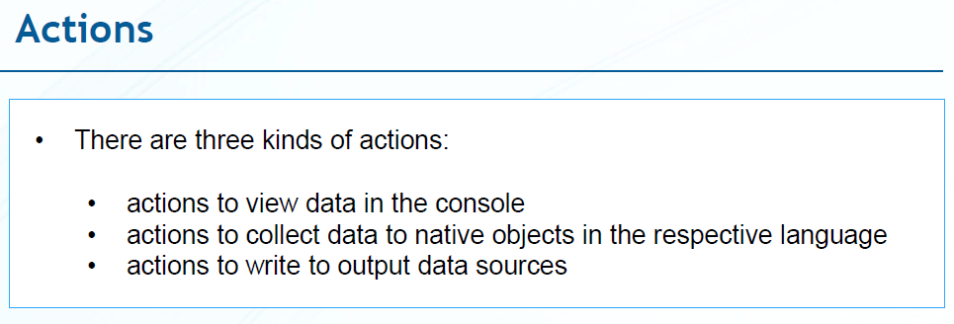



LAZY EVALUATION

Transformations are not executed until an action is called.

Defining transformations but no computation until action:

rdd2 = rdd.map(x => x * 2);

rdd2.count().



